1. What attribute is used to allow the new controller to respond to web API requests?

[ApiController]

1. How does the controller ensure that there is never an empty to do list?

if (_context.TodoItems.Count() == 0)

{

// Create a new TodoItem if collection is empty,

// which means you can't delete all TodoItems.

_context.TodoItems.Add(new TodoItem { Name = "Item1" });

_context.SaveChanges();

}

1. Run the app. Do 3 screen prints for all to do items, just item 1, and just item 2. Notice the difference in JSON for each response.

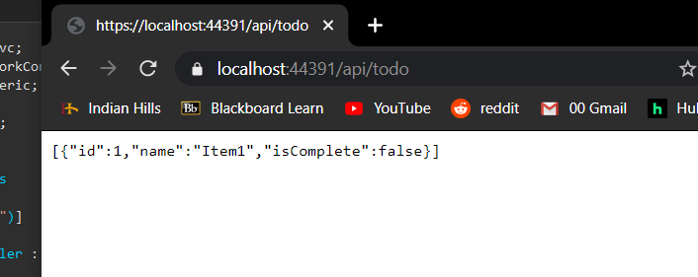

1. What attribute controls how the URL for the HTTP Get request is configured?

[HttpGet]

1. Briefly describe what a route template does.

Routes describe how URL paths should be matched to actions. Routes are also used to generate URLs (for links) sent out in responses.

1. What is the return type from the HttpGet requests, and why is there a difference in the return type when requesting api/todo versus api/todo/1?

ActionResult<T>type, when you type in “api/todo” it will return the list of items todo, when you type in “api/todo/1”

1. What is the HTTP response code when an item(s) is found, and when not found?

If there are item matchs then, returning item results in an HTTP 200 response. If there are no matching IDs then the method returns a 404 NotFound error code.

1. After installing Postman, do a screen print of a Get request.

